WALKER

User Manual

- Parts of the Walker
- Methods of the Usage and Operation

Walker (DY04962L, DY4961L, DY04965L, DY04965L-5, DY04912L-5, DY04912L-2.5, DY04919L, DY04915L, DY04912L(S)-5 ,DY04913L(S), DY04913L, DY04966L(S)-2.5, DY04966L(S)
  - Parts of the Rollator
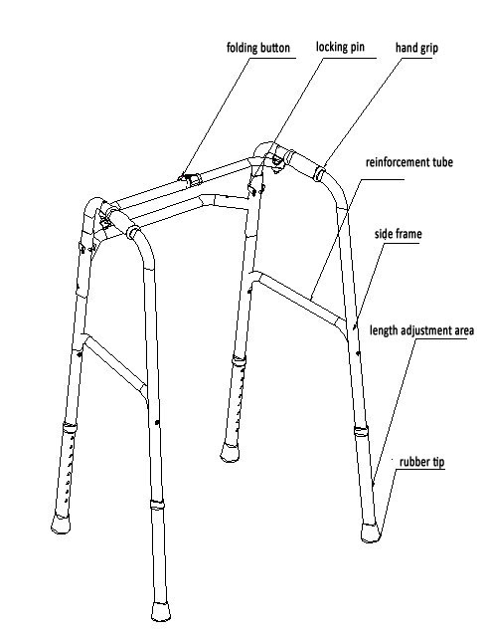
  - Methods of the Usage and Operation
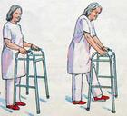
1). Walking:
First, put your walker about one step ahead of you, making sure the legs of your walker are level to the ground. With both hands, grip the top of the walker for support and walk into it, stepping off on your injured leg. Touch the heel of this foot to the ground first, then flatten the foot and finally lift the toes off the ground as you complete your step with your good leg. Don't step all the way to the front bar of your walker. Take small steps when you turn.

(2). Sitting:
- Sit in firm, straight-backed chairs with high seats and armrests. You should avoid low, overstuffed chairs. Back your walker up until you feel the chair touching the back of your legs.
- Release your hands from the walker and reach down and hold onto the arm rests. Slowly lower yourself keeping your operated leg straight out in front.
- Sit then slide back in the chair bending your unoperated leg first. You use this technique when using a toilet with arm rails as well.
